Jenkins lab 1

Part 1 – Explore IDE and create a Jenkin job

Objectives
- In this part you will install Jenkins using Docker technology.
- Investigate the Jenkins IDE.
- Create a basic Job and explore its options

Install Jenkins using Docker
Usually Jenkins has its own dedicated server but for this exercise we need to set one up quickly using Docker.
docker run -d -p 8080:8080 -p 50000:50000 -v jenkins_home:/var/jenkins_home jenkins/jenkins:lts
- Get the Jenkin’s docker ID (docker ps).
In this example we assume the ID starts with e7b
- Run the following command to get the Jenkins secret password:
docker exec -it e7b cat /var/jenkins_home/secrets/initialAdminPassword
copy the secret password
- In a browser type: localhost:8080
Copy the secret Administrator password from the previous step and paste here:
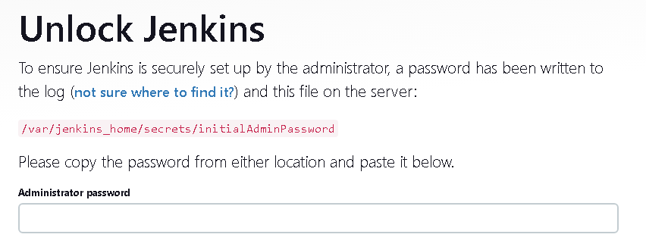
- Install the suggested plugins
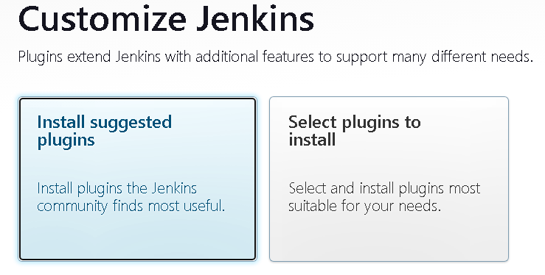
- Create the admin user (any name and password will do. The email is not checked)
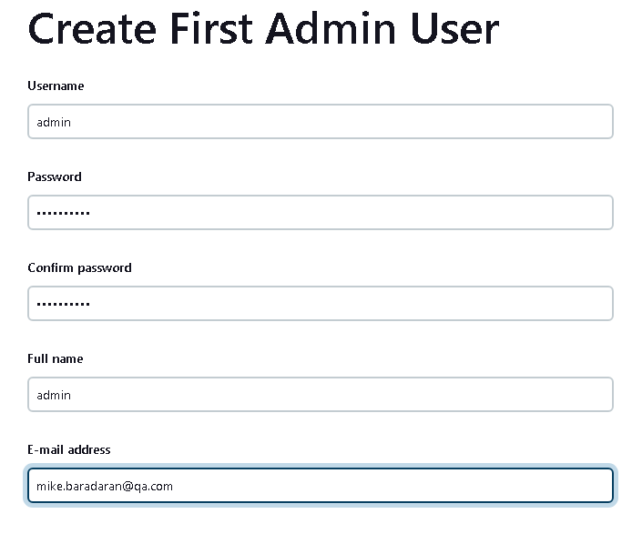
- Follow the rest of the dialogs
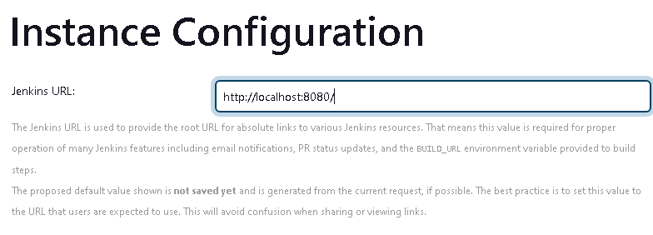
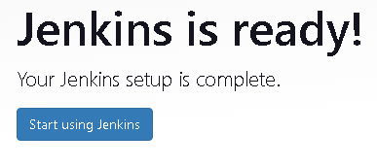
- Create a new job by clicking [+ New Item]
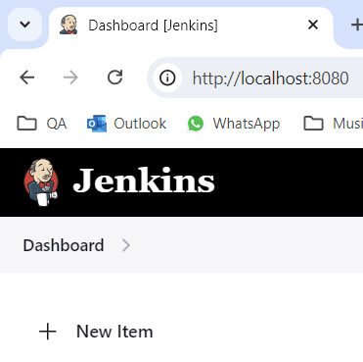

- Choose a name for this job
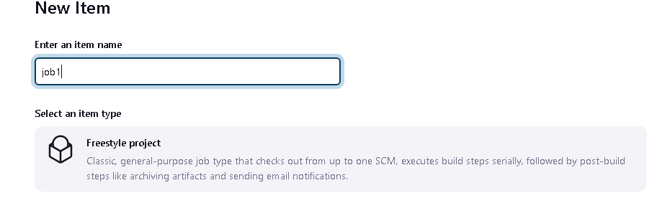
- Scroll down and find the Buil Step section and then select these options:
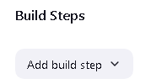
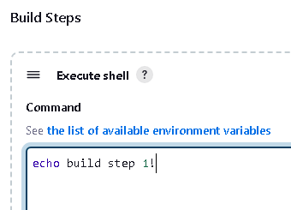
We will not deploy an application, only a simple script to get to know this tool.
- Click Save and then 
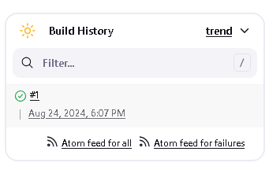
- Click on #1 (build number) and then click
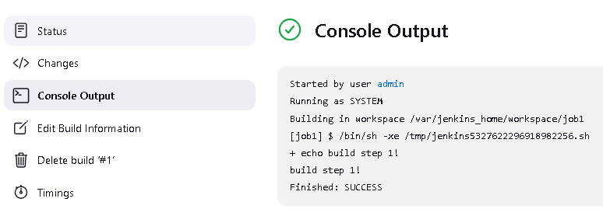
- Jenkins provides many environmental variables. We will have a look at a few. View these by clicking on the link.
- Click on job1 title and then select the configure option
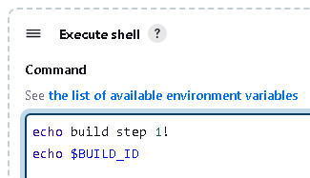
- Click
- View the Console log and note the BUILD_ID value.
- Modify Job1 by adding a few more lines
(Execute shell) 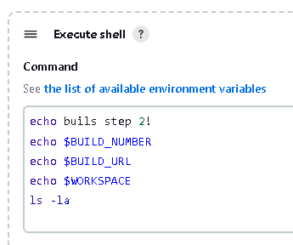

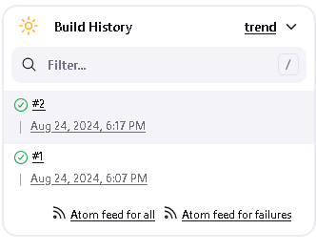
- View the console log
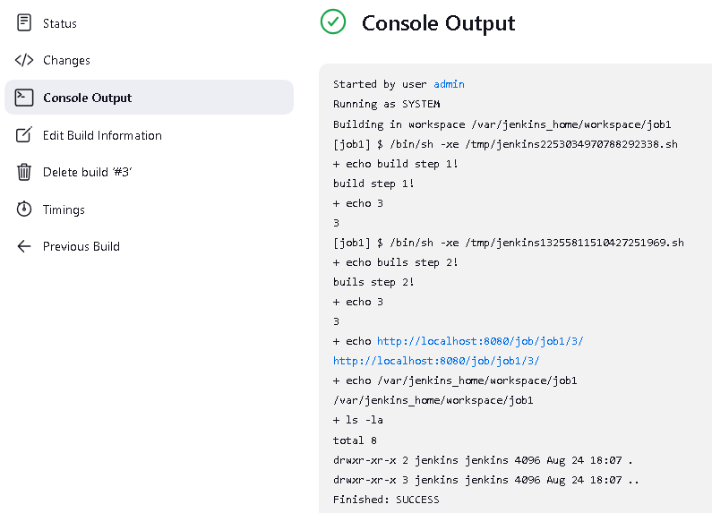
- Add another step to the build to execute a shell command to reference Jenkin’s Workspace
which is a directory on the Jenkins server where the files related to a specific job are stored during the build process. The following command create a file called file.txt with content of “QA Training”.
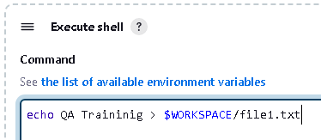
- Lokk for the Job 1’s Workspace menu and display the content of file.txt
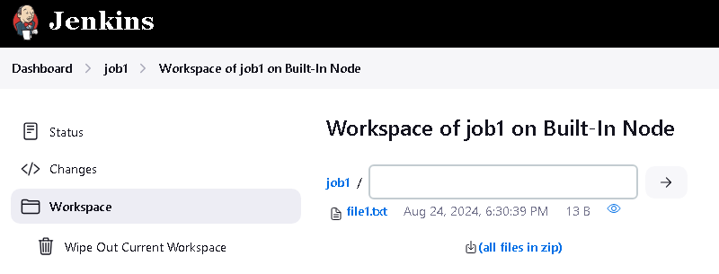

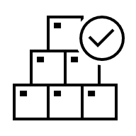Congratulations, you have successfully created a job using Jenkins and explored it’s various IDE options.
Please continue to Part 2 below.

Part 2- Triggers

Objectives
In this part you will create a Jenkin trigger, and explore other forms of triggers in other labs.
Trigger is an event or action that initiates the execution of a job or pipeline (we will explore pipelines later).

Create a Remote build trigger

- Configure Job1 and find the Buil Triggers section
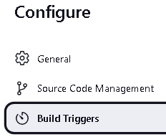
- Create a token for invoking and API end point for triggering a build (any secret token word will do)
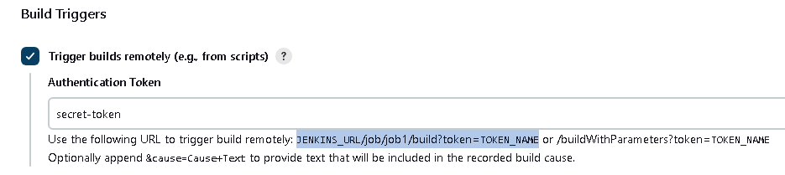


- Make a change to the last build and then save.
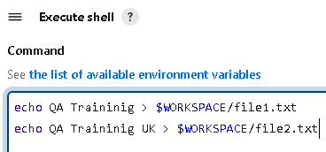

- Type the following text in a browser and click the Proceed button to trigger the build.
Please note, this will result in a blank screen and will only shows errors if there are any.
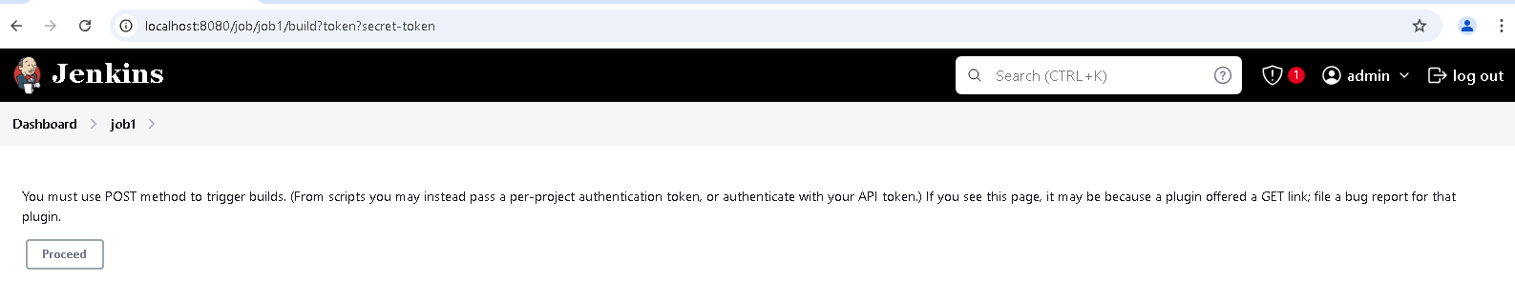
http://localhost:8080/job/job1/build?token?secret-token

- As mentioned, the screen will go blank but a new build is triggered (please wait a moment until it does)
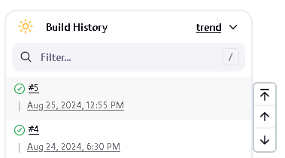

Congratulations, you have successfully created a Jenkins trigger. This is an important concept and you will explore other forms of Jenkin’s Triggers in other labs.
Please continue to Part 3 below.

Part 3 - Chaining project builds

Objectives
In this part you will chain 2 or more builds together.
Build chaining in Jenkins automatically triggers one or more jobs after another job completes. This enables multi-step automation pipelines, where one job’s output becomes the next job’s input.
- Create a new Job called job2
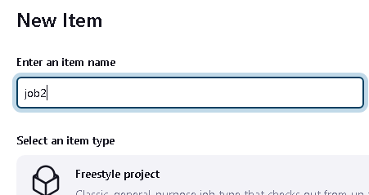
- Assign a build step like
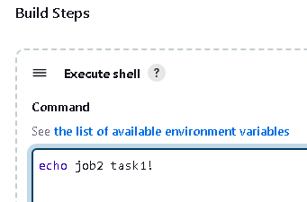

- Configure Job1’s post-build action to trigger building Job2
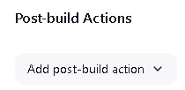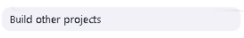
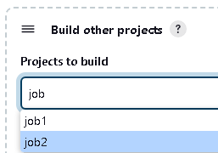

- Build Job1  and note that both jobs get built
View the console output of Job1 and Job2 for proof
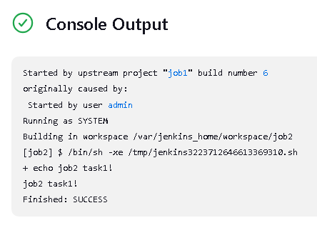
- View Job1’s status for the Downstream project (Job2)
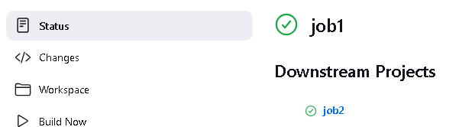

Congratulations, you have successfully created a Jenkins build chain.
Please continue to Lab2 to explore building and deploying a Maven app stored on GIT.

